**DAILY ONLINE ACTIVITIES SUMMARY**

|  |  |  |  |  |  |  |  |  |
| --- | --- | --- | --- | --- | --- | --- | --- | --- |
| **Date:** | **14/07/2020** | | | | | **Name:** | **NAIPUNYA VINOD NAIK** | |
| **Sem & Sec** | **IV SEM & A SECTION** | | | | | **USN:** | **4AL18CS050** | |
| **Online Test Summary** | | | | | | | | |
| **Subject** | | **NO INTERNALS CONDUCTED** | | | | | | |
| **Max. Marks** | | **30** | | **Score** | | | **------------------** | |
| **Certification Course Summary** | | | | | | | | |
| **Course** | **1)** **THE COMPLETE ANDROID ETHICAL HACKING PRACTICAL COURSE C**  **2) GOOGLE CLOUD PLATFORM BIG DATA AND MACHINE LEARNING FUNDAMENTALS** | | | | | | | |
| **Certificate Provider** | | | **1) UDEMY**  **2)COURSERA** | | **Duration** | | | **1) 5.5 HRS**  **2) 2 WEEKS** |
| **Coding Challenges** | | | | | | | | |
| **Problem Statement: 1)** [Write a java program to check for balanced parenthesis](https://github.com/orgs/alvas-education-foundation/teams/2nd-year/discussions/150). | | | | | | | | |
| **Status: EXECUTED** | | | | | | | | |
| **Uploaded the report in Github** | | | | | **YES** | | | |
| **If yes Repository name** | | | | | <https://github.com/naipunya-naik/lockdown-coding/blob/master/JAVA%20CODING/BalancedParanthesis_14-07-2020.java> | | | |
| **Uploaded the report in slack** | | | | | **YES** | | | |

Online Test Details: (Attach the snapshot and briefly write the report for the same).

NO INTERNALS CONDUCTED

Certification Course Details: (Attach the snapshot and briefly write the report for the same).

CERTIFICATION COURSE NAME:- THE COMPLETE ANDROID ETHICAL HACKING PRACTICAL COURSE C

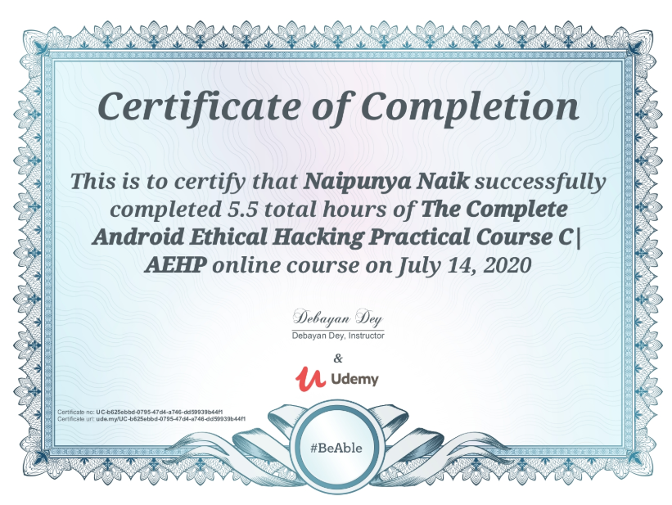

2) CERTIFICATION COURSE NAME:-

**GOOGLE CLOUD PLATFORM BIG DATA AND MACHINE LEARNING FUNDAMENTALS**

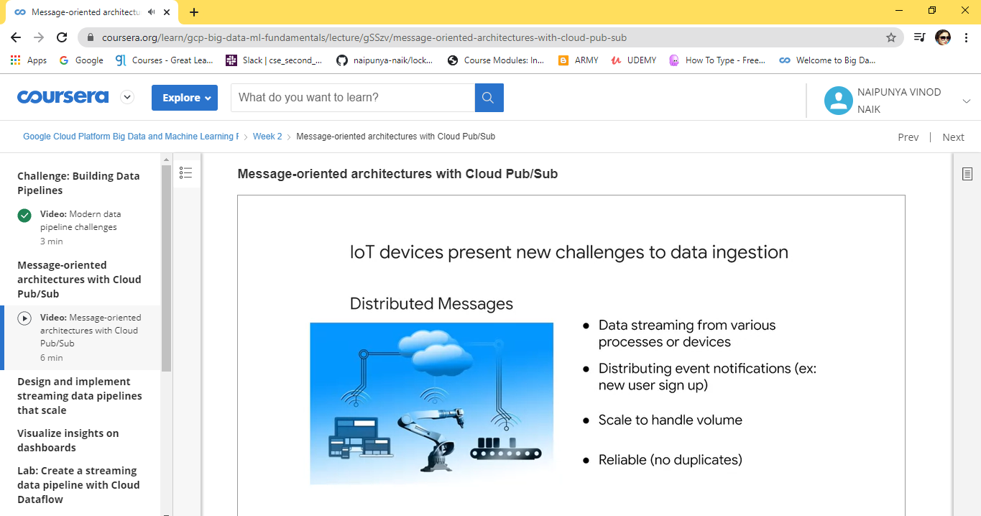

Coding Challenges Details: (Attach the snapshot and briefly write the report for the same).

PROBLEM STATEMENT:- Write a java program to check for balanced parenthesis.

Top of Form

Bottom of Form

|  |
| --- |
| Given an expression string exp. Examine whether the pairs and the orders of “{“,”}”,”(“,”)”,”[“,”]” are correct in exp. For example, the program should print 'balanced' for exp = “[()]{}{[()()](https://github.com/orgs/alvas-education-foundation/teams/2nd-year/discussions/150)}” and 'not balanced' for exp = “[(])”  Input: Input consists of a string of expression, in a separate line.  Output: Print 'balanced' without quotes if the pair of parenthesis is balanced else print 'not balanced' in a separate line.  Example: Input: {([])} () ([]  Output: balanced balanced not balanced |

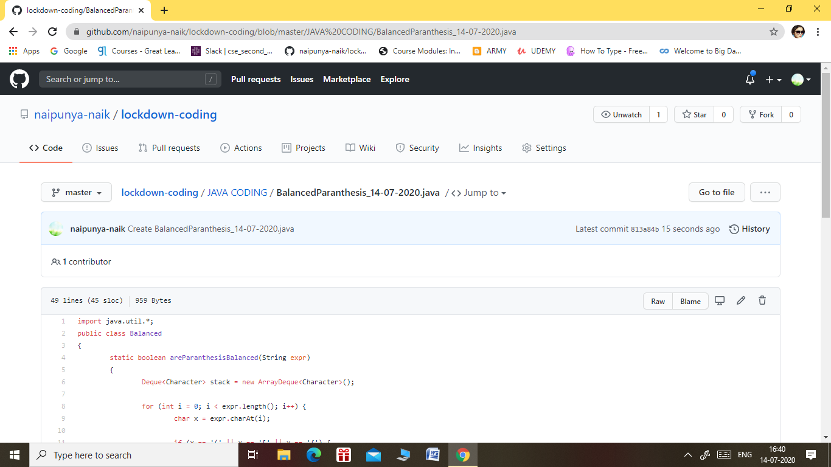

GITHUB REPOSITORY LINK:-

<https://github.com/naipunya-naik/lockdown-coding/blob/master/JAVA%20CODING/BalancedParanthesis_14-07-2020.java>